1. Make sure you have a gmail account and you are logged in with it in google chrome
2. Go to <https://colab.research.google.com/>

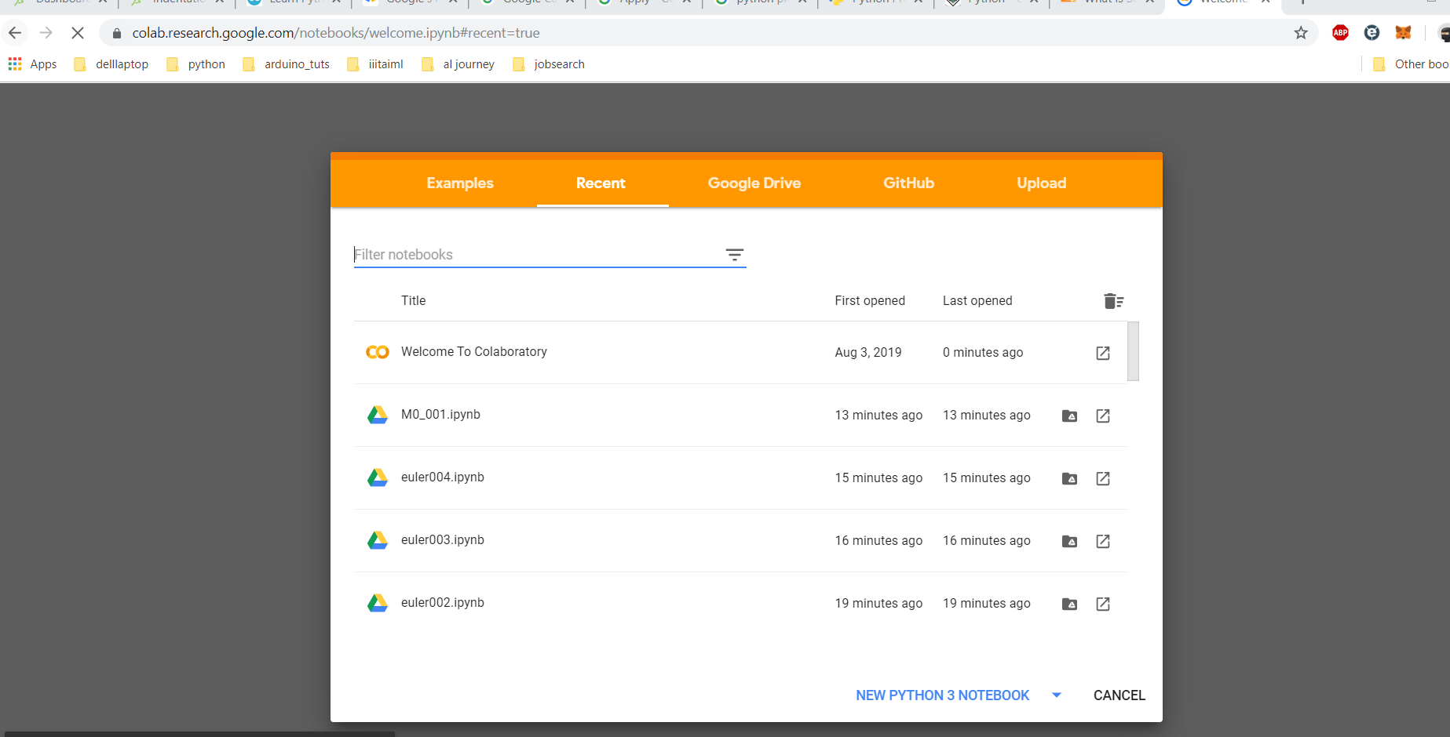

1. Click on Upload tab
2. Click on “Choose file” button
3. Below screen should appear:

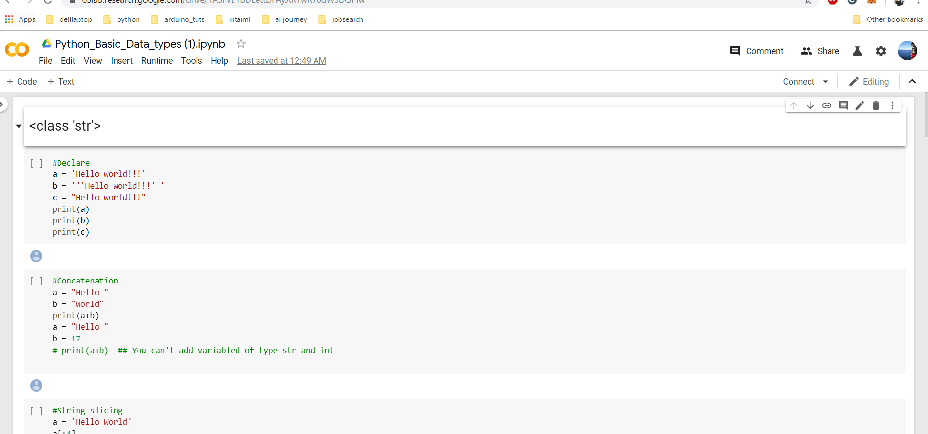

1. Click on ‘Connect’ (Top right link), proceed once it changes to below icon :

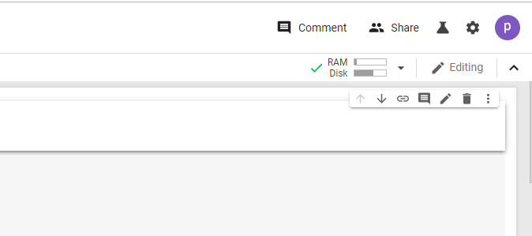

1. To run a cell click on the ‘play’ button or press Shift+Enter .